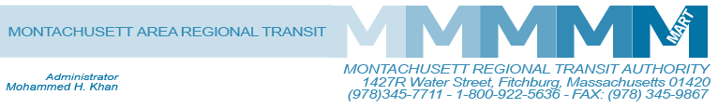

Posted 03/16/2015 at 11:05 am by JAV

MART Maintenance Facility
1427R Water Street
Fitchburg, MA 01420

MEETING OF THE MART Finance/Executive Compensation COmmittee
Tuesday, March 24, 2015
2:00 P.M.

Agenda

- Approval of Meeting Minutes, February 6, 2014, April 15, 2014, April 28, 2014, October 14, 2014
and January 13, 2015.
- Introduction to James Sluss, MART Controller effective March 16, 2015
- Hiring of a Financial Planner and Analyst
- Review of 7 Month Expenditures and Revenue
- FY2016 Draft Budget
- Proposed Fare Increase/Public Hearing
- Executive Compensation Plan
- General Comments
- Adjournment
C: City and Town Clerks: Please post this notice pursuant to MA General Laws Chapter 30A,
Sections 18-25.

